Palm Beach County Housing Summit 2017:

SOLUTIONS FOR INCREASING ATTAINABLE HOUSING IN PALM BEACH COUNTY

White Paper

**I. Introduction**

1. ***Overview***

The 2017 Palm Beach County Housing Summit strives to bring together a diverse group of community leaders, professionals and stakeholders, across many jurisdictions and specialties, to address this critical community-wide issue. Attainable housing is a goal of the entire community, and not the responsibility of a single entity or agency. The challenge is to identify and garner support for a shared, sustainable framework that will increase housing attainable to all our Palm Beach County residents. The focus will be on reducing financial, policy and regulatory barriers while exploring innovative tools and models that will provide additional housing options and build on the efforts to keep pace with growth in our county.

According to data published by the Florida Housing Data Clearinghouse, in 2015 approximately 45% of Palm Beach County households paid more than 30% of income for housing, and about 23% paid more than 50% of income for housing. The objective of ‘attainable housing’ efforts is to increase the number of units available to residents in the appropriate price ranges, so that the number of cost-burdened households is minimized and the community can sustain the workforce necessary to provide the services and conveniences it expects. The marketplace typically does not provide sufficient units at the lower price levels which are necessary to relieve existing cost-burdened residents, and provide housing for anticipated new residents, including young adults leaving their parents’ home or senior citizens and retirees. Additional tools and approaches become necessary to encourage or require the delivery of units.

This White Paper is a primer for all Summit attendees, to provide an overview of the attainable housing issue, along with key challenges and existing programs, and provide a basis for discussion of ways to increase available housing units, types of housing, and access to attainable housing. We strongly encourage all attendees to read this White Paper before the Summit.

***B. Definitions***

“Attainable Housing” is housing for which the occupants pay no more than 30% of household income toward housing expenses, which may include rent or mortgage, utilities, taxes, association fees and insurance.

The “Area Median Income” (AMI) for Palm Beach County, in 2017, is $67,900 for a household of four. *Source: FL Housing Finance Corporation website, 2017 Income Limits FDIC AHP 4/14/17.* A breakdown of households in Palm Beach County by percent of AMI appears in Appendix B. In 2014, 63% of Palm Beach County households had incomes in the range of 0 to 120% of AMI.

“Cost-burdened” describes the situation wherein occupants of housing pay more than 30% of household income toward housing expenses. The percentage of population which is cost-burdened is an indicator of the severity of the attainable housing problem in a community. The following tables detail cost burden by income level and by owner/renter status:

**PBC Households by Income and Cost Burden, 2015**

|  |  |  |  |
| --- | --- | --- | --- |
| **Household Income as**  **Percentage of Area**  **Median Income** | **Amount of Income**  **Paid for Housing** | | |
| **0-30%** | **30-50%** | **50% or more** |
| **<=30% AMI** | 6,307 | 7,686 | 59,655 |
| **30.01 - 50% AMI** | 14,173 | 22,400 | 35,627 |
| **50.01 - 80% AMI** | 38,899 | 35,259 | 23,520 |
| **80.01 + % AMI** | 258,340 | 57,623 | 15,201 |
| **Total** | **317,719** | **122,968** | **134,003** |

**PBC Households by Owner/Renter Status and Cost Burden, 2015**

|  |  |  |  |
| --- | --- | --- | --- |
|  | **Amount of Income**  **Paid for Housing** | | |
| **0-30%** | **30-50%** | **50% or more** |
| **Owner** | 246,122 | 84,201 | 81,827 |
| **Renter** | 71,597 | 38,767 | 52,176 |

*Source: Data published on the Florida Housing Data Clearinghouse website,* [*http://flhousingdata.shimberg.ufl.edu/a/profiles?action=results&nid=5000*](http://flhousingdata.shimberg.ufl.edu/a/profiles?action=results&nid=5000)

**II. Overview of Housing Values in Palm Beach County**

To obtain a sense of the scope of the workforce housing situation in PBC, Property Appraiser data (2016 1st certified tax roll) for values of residential parcels were analyzed relative to the value range associated with the PBC Workforce Housing Program. Parcel values were increased by 15%, to reflect the difference between the Property Appraiser’s market value and actual market value, and parcels valued above $1,000,000 were excluded. The resulting data for 36 jurisdictions were then analyzed against the 2016 top sales price associated with the PBC Workforce Housing Program, $255,060.

Per the 2016 First Certified Tax Roll (Fall 2016), which is based on 2015 market values, sixty percent of all parcels countywide are valued under $255,060. Nine of the 36 jurisdictions have 90% or more of their parcels valued under $255,060, and 10 jurisdictions have fewer than 40% of their parcels valued under the $255,060 threshold. Six local governments account for 75% of all parcels countywide valued under $255,060; unincorporated PBC accounts for nearly 2/3 of that. Looking only at municipalities (excluding unincorporated PBC), 7 municipalities account for 35% of parcels valued under $255,060. See Appendix H for Property Appraiser tables.

It is important to note that the data, 2016 First Certified Tax Roll (Fall 2016) reflect Property Appraiser ‘market values’ as of January 1, 2016, and would not capture significant value increases after that date. For example, the median sales price of single-family homes rose from $298,450 in March 2016 to $325,000 in March 2017, an 8.9% increase. The 15% upward adjustment of the data is likely not sufficient to reflect this increase, as well as the difference between actual market value and the ‘market value’ attributed by the Property Appraiser.

In addition, we must also consider 'cost-burden' data, which provide a better indication of any mismatch between the available units and the available household income. In addition, these values do not account for properties which may be unattainable for other reasons—for example, units in age-restricted developments, substandard units requiring rehabilitation, units reserved for seasonal use, or units requiring substantial additional costs or fees, such as HOA fees.

**III. Key Challenges**

Many issues affect the provision of attainable housing in the Palm Beach County community. Some key challenges include:

* **Broadening Participation in the Solution**

Achieving attainable housing for a community is a complex issue that requires a multi-faceted approach. In a large and diverse community such as Palm Beach County, it cannot be the sole responsibility of one local government or one agency. Of Palm Beach County’s total population, 56% is within municipalities. Attainable housing requires complementary, collaborative efforts among federal, state, local and non-profit agencies, cities and county, developers of housing and non-residential uses, employers, business and education leaders, and residents, as the entire community benefits from a sustainable, viable workforce. *Source of Population: 2016 Bureau of Economic and Business Research (BEBR)*

* **Housing Cost Variations Across Jurisdictions**

According to other data from the Realtors Association of the Palm Beaches, the median price in January 2017 for single-family homes was $310,000. In addition, the Realtors Association of the Palm Beaches data indicates the median price in March 2017 for single family homes was $325,000, up 8.9% from March 2016 and for condos and townhouses was $162,000, up 4.5% from March 2016. In comparison, as noted above in the definitions section, the median household income in 2017 is $67,900, an increase of 3.8% since 2016. Sales data from by the Florida Department of Revenue, Sales Data Files, for the period 1996 through 2016 are provided in Appendix A.

These countywide median housing values do not reflect that values vary greatly from jurisdiction to jurisdiction. The table below displays prices by local communities which had 50 or more sales. Note that these figures combine houses and condos, and may include age restricted units.

* Boca Raton: $306,000, up 7.4% from January 2016
* Boynton Beach: $221,500, up 8.1% from January 2016
* Delray Beach: $180,000, up 33.3% from January 2016
* Greenacres: $125,505, up 9.6% from a year ago
* Jupiter: $335,750, up 3.8% from a year ago
* Lake Worth: $207,500, down 3% from a year ago
* Palm Beach County: $238,000, up 5.8% from a year ago
* Palm Beach Gardens: $334,250, up 6.1% from a year ago
* Wellington: $339,000, down 5.8% from a year ago
* West Palm Beach: $160,000, up 6.7% from a year ago
* **Location/Transportation**

Transportation is a major factor in the cost-burden analysis. Many families attempt to live farther away from employment centers to reduce their housing cost burden; however, in doing so, their transportation costs increase dramatically. A combined housing plus transportation cost burden is a key factor to understanding the problem of affordability. In Palm Beach County, an average of 67% of a household’s income goes towards transportation and housing costs. *Source: Center for Neighborhood Technology H+T Affordability Index http://htaindex.cnt.org/map/*. These combined costs are also a major issue for Palm Beach County businesses because they impact employee recruitment and retention. According to the Census 2010 data, the County has 166,415 workers commuting into Palm Beach County from Broward, Miami-Dade, Martin and St. Lucie Counties. This may be an indication of the problem of housing affordability.

* **Land Availability and Costs**

The map in Appendix C illustrates that few large vacant parcels remain in the urban area of Palm Beach County, and increasing land prices reflect this limited availability.

* **Infill and Density**

As the availability of large vacant parcels diminishes, interest grows in redevelopment and infill development, which by definition is surrounded by existing development that may not welcome increased development and its impacts, particularly if the new development is thought to potentially lower property values. A key challenge is to find development techniques and patterns that can be compatible with existing surrounding development, and to educate existing residents regarding the proposed development.

* **Salary Structure**

As the price of housing in Palm Beach County has continued to rise, household income has remained rather stagnant, as demonstrated by the chart below.

**Median Family Income, per HUD**

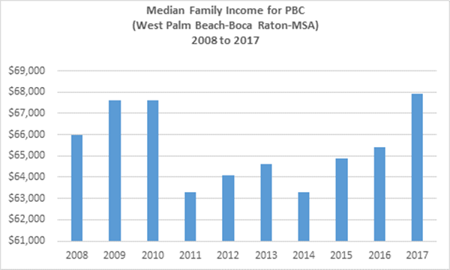

*Source: U.S. Department of Housing and Urban Development*

* **Housing for Homeless Persons**

Palm Beach County’s 2015 Point In Time count (PIT) indicated that 1,421 persons were homeless on the day of the count with 596 of those individuals sheltered and 825 unsheltered. Of those experiencing homelessness, 25% (355 persons) had been homeless for more than 3 months but less than one year, while 47% (667 persons) had been homeless for one year or longer. Twenty-eight percent (28%) of the total homeless population on a given day have experienced homelessness four (4) or more times during a three (3) year period while 32% have experienced one prior episode of homelessness and 15% had no prior episode of homelessness. Finding and maintaining employment and locating affordable housing are the top reasons, persons exit homelessness. *Source: Palm Beach County FY 2015-2020 Consolidated Plan*

* **Housing for Special Needs Populations**

The non-homeless special needs population is comprised of the elderly; persons with mental, physical, and/or developmental disabilities; persons with alcohol or other drug addiction; persons with HIV/AIDS and their families; victims of domestic violence, dating violence, sexual assault, and stalking; veterans; youths aging out of foster care; and ex-offenders. The non-homeless special needs populations experience many of the same housing and service needs and barriers including fixed income, limited income, or no income; lack of available safe, sanitary, affordable housing; lack of housing with supportive services; and, lack of credit history, negative credit or rental history, criminal background, or other factors that affect their ability to find a willing landlord. *Source: Palm Beach County FY 2015-2020 Consolidated Plan*

**IV. Other Challenges**

* Tightened lending requirements and a slowdown of rental housing production during the recession have contributed to subsequent escalation of rental unit costs.
* Cash buyers and investors have consumed the otherwise available supply of housing attainable for households in the 60-140% AMI range. During the past 12 months, 9,971 of 25,670 sales have been transacted as all cash transactions. *Source: Realtors Association of the Palm Beaches*
* Insurance and Homeowners Association/Condominium Association Fees make otherwise affordable housing unaffordable.
* The condition of many attainable homes on the market requires a substantial amount of Rehab; yet an appropriate financing mechanism to allow first time homebuyers to take advantage of these opportunities is lacking. The Palm Beach County FY 2015-2020 Consolidated Plan cites American Community Survey data supplied by HUD which indicates that 33% of owner-occupied units and 41% of renter-occupied units in Palm Beach County were built prior to 1980 and over thirty years old. *Source: PBC Department of Economic Sustainability July 2015*
* Borrowers have been burdened by student loan and other debt which may affect their ability to obtain financing.

**V. Existing Programs and Solutions**

1. ***Local Government Assistance Programs***

Local governments administer housing assistance programs. In addition to Palm Beach County, the County has 7 entitlement municipalities who receive their own federal housing funding allocations: Boca Raton, Boynton Beach, Delray Beach, Jupiter, Palm Beach Gardens, Wellington, and West Palm Beach. These municipalities administer different, but somewhat similar, housing assistance programs. The funding allocations are limited on an annual basis and the demand for the programs tend to exceed available funding. Palm Beach County programs are available for residents within non-entitled municipalities and within unincorporated areas. An outline of the housing assistance programs that are administered by Palm Beach County are included in Appendix D, and summarized below. These include:

* Housing Finance Authority: homebuyer mortgage programs and financing for affordable housing development or rehabilitation
* Palm Beach County Department of Economic Sustainability: purchase assistance, emergency repairs, foreclosure prevention, housing rehabilitation, veterans’ homeownership and preservation, first mortgage loan program, developer assistance, neighborhood stabilization and disaster mitigation
* Community Services: Rental Housing Entry Assistance, Tenant based Rental Assistance, Homelessness Prevention and assistance programs, Human and Veteran Services, Housing and Utility Assistance

1. ***Inclusionary Zoning Programs***

Several local governments in Palm Beach County implement inclusionary zoning or other attainable housing programs:

1. **Palm Beach County – Workforce Housing Program**

Palm Beach County’s Workforce Housing Program (WHP) enacted in 2006 is an “inclusionary zoning” ordinance that requires or encourages developers to sell or rent a certain percentage of residential units in a new development at prices affordable to households having 60% to 140% of AMI in developments of 10 or more units. A description of the County’s WHP and breakdown of new residential projects in Palm Beach County with WHP units is attached in Appendix E. The WHP provides a number of benefits to developers in exchange for developing such workforce housing including: an optional density bonus, relief from some property development regulations, and relief from some Traffic Performance Standards. The program also offers the option of constructing workforce housing units on site or off site in lieu of building the workforce units, to make a donation of buildable land to meet a developer’s WHP obligation, or to make an in-lieu fee payment ($81,500 per for-sale unit and $50,000 per rental unit) to meet the workforce housing unit obligation.

1. **City of Delray Beach – Family/Workforce Housing Program**

This Program, enacted by Ordinance No. 66-04 in December 2004, is applied to residential development located within various Overlay Districts and Infill Workforce Housing Areas identified by the City. Incentives available to residential developers include a density bonus and an increase in height of structures when providing the workforce units. Developers can build units on-site, off-site or pay an in-lieu fee ($160,000) per workforce unit.

1. **Town of Jupiter – Workforce Housing Program**

This Program was enacted by Ordinance No. 7-15 in May 2015, and is applied to residential development of 10 units or more located within the Town. Incentives available to residential developers include a density bonus, an exception to the Town’s traffic performance standards and expedited review. Developers can build units on-site, donate buildable land or pay an in-lieu fee: $200,000 per for-sale WHP unit and $150,000 per rental WHP unit.

1. **City of West Palm Beach – Housing Assistance Incentives Program**

This Program, enacted by Resolution No. 84-16 in March 2016, promotes the development of affordable and workforce housing units for developments that complete an application process. Following that process, developments certified as an Affordable, Attainable or Workforce Housing projects are eligible to receive incentives that include various fee waivers or reductions, parking requirement reductions, use of City-owned lots, and the possible receipt of City housing funds through loans and grants.

1. ***Community Land Trust***

Community Land Trusts (CLTs) are nonprofit organizations that provide lasting community assets and permanent affordable housing opportunities for lower-income families. A one-time public investment is used in a self-sustaining way to keep homes forever affordable to families with modest incomes. CLT’s invest public funds into a property to make home purchase affordable for a lower-income family.

The land is owned and preserved by the CLT and the homeowner owns the home and all the improvements. Exclusive use of the land is provided through a renewable 99 year ground lease. Under this model, the CLT supports the family to attain and sustain homeownership. In return, the homeowner agrees to sell the home at an affordable price to another lower-income homebuyer in the future. Consequently, the family is able to successfully own a home and build wealth, while the program is able to preserve the public’s investment in the home permanently to help family after family. A snapshot of the number of units provided through the Community Land Trusts in Palm Beach County is provided below.

**Community Land Trusts in Palm Beach County**

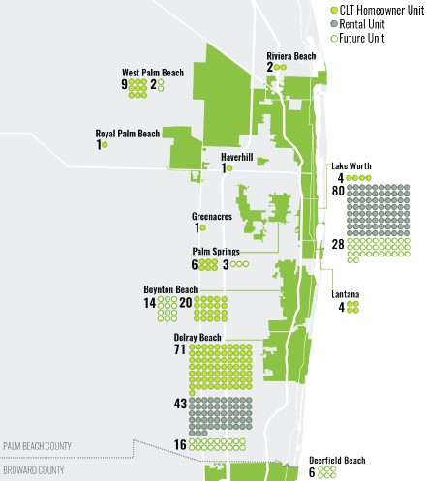

*Source: South FL Community Land Trust Network's 10 Years of*

*Community Land Trusts in South Florida, April 2016 Report*

1. ***Government-owned Land***

Property owned by municipal and county governments is also a potential source of land for residential development. A list of Palm Beach County surplus property is attached hereto as Appendix F. Some of the listed parcels are under consideration to be donated to nonprofits. Inclusion on this list is not a representation of actual availability or dedication for residential development. Civic sites, parks, preserves, trails etc., owned by the County are not included in this list. Local governments can acquire land through tax deeds or donations and may offer land to developers to build homes. Palm Beach County has provided land for infill and redevelopment and actively provides opportunities to non-profit organizations. The Palm Beach County School Board also owns various surplus properties that may be targeted for residential development.

1. ***CRAs***

Under Florida law (Chapter 163, Part III), local governments are able to designate areas as Community Redevelopment Areas when certain conditions exist. Since all the monies used in financing CRA activities are locally generated, CRAs are not overseen by the state, but redevelopment plans must be consistent with local government comprehensive plans. CRAs are a specifically focused financing tool for redevelopment. Examples of traditional projects include: streetscapes and roadway improvements, building renovations, new building construction, flood control initiatives, water and sewer improvements, parking lots and garages, neighborhood parks, sidewalks and street tree plantings. A map of those areas of Palm Beach County in which a CRA operates is provided in Appendix G attached hereto. *Source: Palm Beach County GIS Map System*

1. ***Housing Authorities***

Palm Beach County is home to 7 public housing authorities: Palm Beach County, Riviera Beach, West Palm Beach, Delray Beach, Boca Raton, Pahokee and Belle Glade. Approximately 27,500 persons are receiving housing assistance from federal programs in Palm Beach County, through public housing (2,179 units) or voucher assistance (7,000 Section 8 vouchers), with thousands on waiting lists.

1. ***Non-profit Developers***

Non-profit developers utilize a variety of funding sources to serve a continuum of housing needs for the homeless, individuals with special needs, elderly, re-entry, and working families of moderate means. The following resources/programs are utilized to meet these needs: SHIP, HOME, NSP, CDBG, LITC, FHLB AHP, DCF, FL CCTP, TIF and private funds/grants. Large non-profit organizations in Palm Beach County include: Adopt-A-Family of the Palm Beaches, Community Land Trust of Palm Beach County, Community Partners, Delray Beach Community Land Trust, Gulfstream Goodwill Industries, Habitat for Humanity Palm Beach County, Habitat for Humanity South/Heartfelt Community Land Trust, Lords Place, Neighborhood Renaissance, New Urban Community Development Corporation, and Riviera Beach Community Development Corporation.

1. ***Market Rate Developers***

Some market rate developers construct units that fall within the ranges targeted in attainable housing, either as single units in infill situations, or as entire projects or portions of projects. There is no assurance that market rate units will remain affordable.

**VI. Conclusion**

As Summit participants discuss means to increase housing attainable to all Palm Beach County residents, participants are encouraged to give consideration to a broad range of tools and approaches. Our community faces a number of challenges. Notwithstanding all of the existing programs and tools in place, there remains a need to increase collaborative efforts to produce more attainable housing. Summit participants are encouraged to be part of the conversation and provide input, including innovative ideas and solutions, to build on existing resources and include external partners in this ever-challenging community-wide issue. It will take all of us working together to provide sufficient attainable housing.

PALM B E ACH COUNTY HOUS ING SUMM IT STEE RING C O MMIT T EE

Derrick Berry

Buccaneer Mortgage

Suzanne Cabrera

Housing Leadership Council

Patrick Eichholtz

JP Morgan Chase

Armando Fano

Director, Housing and Community

Development

City of West Palm Beach

Patricia Fitzgerald

Illustrated Properties

Dennis Grady

Chamber of Commerce of the Palm Beaches

Annetta Jenkins

Director of Neighborhood Services, Riviera

Beach CRA

Faye Johnson

Assistant County Administrator

David Kanarak

Pulte Homes

Dr. Gonzalo La Cava

Chief of Human Resources, PBC School District

Cindee LaCourse- Blum

Executive Director, Community Land Trust of Palm Beach County

Matthew Leger

Realtors Association of Palm Beach County

Skip Miller

Attorney, Greenspoon Marder, P.A.

Kevin Ratterree

Vice President, GL Homes

Rick Reikenis

President, Reikenis & Associates LLC

Jessica Shapiro

Attorney, Gunster

Michael Weiner

Michael S Weiner & Associates, P.A.

Jack Weir

President, Eastwind Development

**APPENDIX A**

**Median Sales Price for Single Family**

**Homes and Condominiums,**

**Palm Beach County 1996-2016**

|  |  |  |  |  |  |  |  |  |  |  |  |  |  |  |  |  |  |  |  |  |  |  |
| --- | --- | --- | --- | --- | --- | --- | --- | --- | --- | --- | --- | --- | --- | --- | --- | --- | --- | --- | --- | --- | --- | --- |
|  | | | | | | | | | | | | | | | | | | | | | | |
| **Place** | **Housing Type** | **1996** | **1997** | **1998** | **1999** | **2000** | **2001** | **2002** | **2003** | **2004** | **2005** | **2006** | **2007** | **2008** | **2009** | **2010** | **2011** | **2012** | **2013** | **2014** | **2015** | **2016** |
| Palm Beach County | Condominiums | 102500 | 103000 | 102500 | 104000 | 120000 | 128345 | 142009 | 172000 | 205000 | 253738 | 272070 | 249550 | 130000 | 95000 | 82000 | 73500 | 79900 | 93000 | 110000 | 121000 | 126000 |
| Palm Beach County | Single  Family  Homes | 127900 | 133000 | 134900 | 142000 | 159000 | 173990 | 197518 | 239665 | 296000 | 370000 | 375000 | 369972 | 285000 | 239900 | 237984 | 235000 | 232000 | 280000 | 311000 | 323000 | 316915 |
| **Sources:**Florida Department of Revenue, Sales Data Files | | | | | | | | | | | | | | | | | | | | | | |

**APPENDIX B**

**Households by Area Median Income**

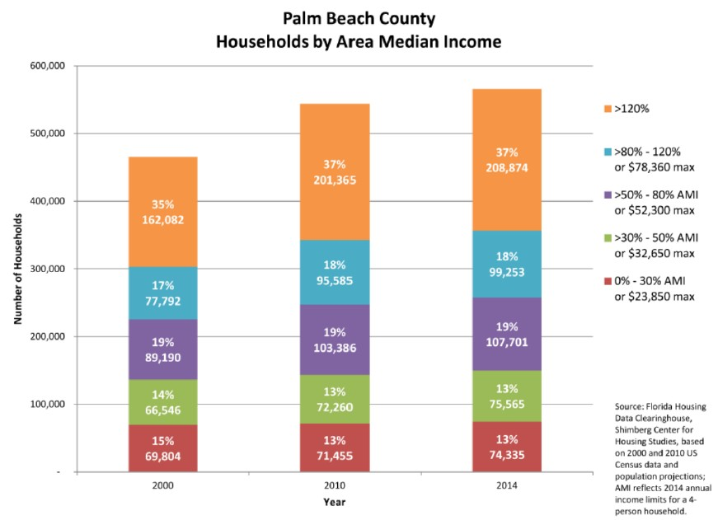

*Chart supplied from Palm Beach County Affordable and Workforce Housing, April 26, 2016 Workshop*

**APPENDIX C**

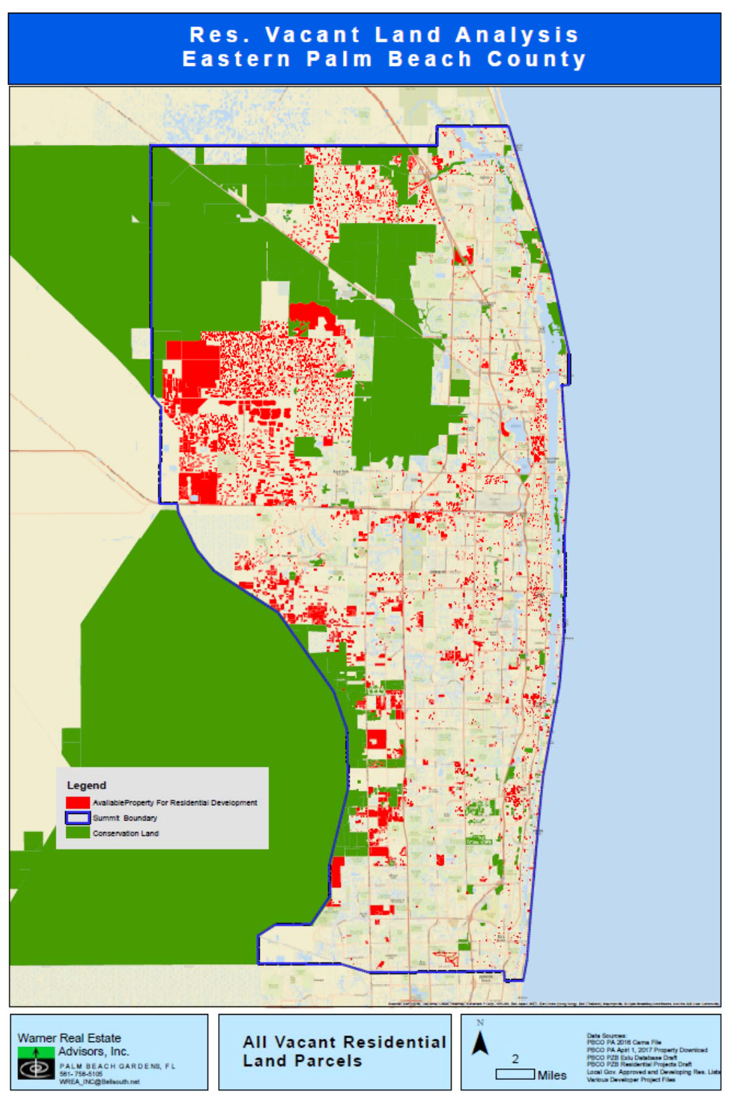

**APPENDIX D**

**Other Governmental Housing Resources**

**GOVERNMENTAL HOMEOWNERSHIP AND ASSISTANCE PROGRAMS**

A summary of housing assistance programs that are administered by Palm Beach County is provided below and sorted by County department.

**Housing** **Finance** **Authority**

* Homebuyer Mortgage Program

o Provides 30‐year fixed rate mortgage with down payment and closing cost assistance

* Mortgage Credit Certificate Program

o Allows 1st time homebuyer to take a portion of their annual mortgage interest as a federal

tax credit

* Multi‐Family Rental Housing Bond Program

o Finances development, acquisition, and rehabilitation of rental housing through tax exempt bonds

o Leverages 4% low‐income housing tax credits

* Revolving Construction Loan Program

o $5 million self‐funded loan pool available to for‐profit or not‐for‐profit affording housing developers for new construction or rehabilitation

**Department** **of** **Economic** **Sustainability**

* Purchase Assistance

o Funding for income eligible first‐time homebuyers for purchase assistance, with or without rehabilitation or new construction, to assist with: gap financing, lot acquisition, down payment, rehabilitation, and closing costs.

o Maximum Awards by Income Category:

* + - * Very Low: $100,000
      * Low $65,000:
      * Moderate: $50,000
* Emergency Repairs

o Funding to income eligible owner occupied residences to address emergency conditions such as roofing, electrical, plumbing, or structural repairs. Funds may also be awarded to pay insurance deductibles for any emergency repairs covered by the homeowner’s policy.

o Maximum Award: $40,000

* Foreclosure Prevention

o Funding to assist with delinquent mortgage payments (Principal Interest Taxes Insurance), including: late fees, attorney’s fees, homeowners’ association payments, special assessments, other foreclosure associated costs, property taxes, homeowners’ insurance, and mortgage delinquency and default resolution counseling.

o Maximum Award: $15,000

* Housing Rehabilitation

o Rehabilitation

* + - * Funding for substantial rehabilitation to: correct code violations or incipient items

that will become a code violation, eliminate housing conditions which threaten the

life, health or safety of occupants, connect residents to public utilities, and adapt residences to meet accessibility needs.

* + - * Maximum Awards by Income Category:
        + Very Low: $75,000
        + Low: $60,000
        + Moderate: $45,000

o Roof Repair/Replacement

* + - * Funding to address deteriorated roofing systems to eliminate substandard or unsafe roofing conditions. Assistance may be provided to homeowners who are at‐risk of homeowners’ insurance policy cancellation or who have received notice of homeowner’s insurance policy non‐renewal for their sub‐standard/deficient roofs.
      * Maximum Award: $35,000

o Utility Connection

* + - * Funding to assist with: sewer and water connection system fees required by local
      * water utilities, and/or costs to install service lines from the meter to the primary residence.
      * Maximum Award: $10,000
* Replacement Housing

o Funding to assist homeowners residing in dilapidated structures which are beyond rehabilitation. Eligible uses of funding include: Demolition of the existing property, construction cost of a replacement home on the same lot or purchase of an existing home, relocation costs, and rent subsidy in conjunction with replacement program.

o Maximum Awards by Income Category:

* + - * Very Low: $215,000
      * Low: $215,000
* Veterans Homeownership & Preservation Program

o Funding to income eligible active duty military personnel and veterans, including eligible surviving spouses of military personnel to acquire a new or existing single family residence or rehabilitate an existing home. Assistance can be used for leveraging with existing veterans housing ownership programs, gap financing, and land acquisition with housing development, down payment assistance, closing costs, and rehabilitation/repair to correct code violations or incipient items that will become a code violation.

o Maximum Award: $100,000

* First Mortgage Loan Program

o Funding for first mortgage loan assistance to income eligible households. Maximum loan amounts are based upon established affordability guidelines and creditworthiness, based upon established underwriting guidelines.

o Maximum Award: $200,000

* Disaster Mitigation

o Funding to income eligible applicants in need of home repairs directly caused by a disaster that is declared by Executive Order of the United States President or the Governor of the State of Florida.

o Maximum Awards by Income Category:

* + - * Very Low: $55,000
      * Low: $45,000
      * Moderate: $40,000
* SHIP Developer Assistance Rental Housing

o Funding to developers and owners of affordable rental housing to construct or rehabilitate affordable rental units. All SHIP assisted units must be occupied by income eligible families.

o Maximum Awards by Income Category:

* + - * Very Low: $40,000 per unit
      * Low: $40,000 per unit
* HOME Developer Assistance

o Funding to developers to construct or acquire/rehabilitate multi‐family rental or single‐

family affordable housing for households at or below 80 percent of Area Median Income.

* HOME Investment Partnership Program

o Funding to assist income eligible very‐low and low income applicants acquire their first home. Assistance may be used for: acquisition, acquisition/rehabilitation, and new construction.

o Maximum Awards by Income Category:

* + - * Very Low: $75,000
      * Low: $65,000
* Neighborhood Stabilization Program (NSP) Developer Assistance

o Funding to developers to redevelop abandoned and foreclosed single and multi‐family properties through acquisition, rehabilitation, and new construction. Projects must create rental or ownership opportunities for households at or below 120 percent of Area Median Income.

**Human** **and** **Veteran** **Services:**

* Rental Housing Entry Assistance

o Funding will provide individuals or families that are in need of one‐time assistance with rental security deposits, utility deposits, connection fees, housing stability counseling, and rental payments equal to no more than 12 months.

o Maximum Award by Income Category**:**

* + - * Extremely Low: $10,000
      * Very Low: $10,000
      * Low: $10,000
* Tenant Based Rental Assistance—Administered by Department of Community Services

o Funding covers the gap between the client’s minimum payment and the actual cost of rent

to homeless individual/family with direct rental assistance in which the recipient tenant may

move from a dwelling unit with a right to continued assistance. Includes security and utility

deposits associated with the rental of dwelling units up to 24 months.

o Rental payments must meet Palm Beach County’s fair market rent standard and must be in compliance with HUD’s standard of rent reasonableness.

o Maximum rent charged cannot exceed 30 percent of the household’s adjusted income.

o Households must be at or below 60 percent of Area Median Income.

* Emergency Food and Shelter Program and Ad Valorem Assistance

o Funding covers cost of rent and utility assistance to prevent homelessness.

o Rental payments must meet Palm Beach County’s fair market rent standard and must

ensure continued housing stability.

o Households must be at or below 150% of Federal Poverty Limit Guidelines.

* Rapid Re‐Housing Assistance

o Funds homeless individuals to move from emergency shelter/streets to permanent housing

o Provides rental and utility assistance for up to 12 to 15 months

o Comprehensive Case Management provided

o Must be Palm Beach County resident and documented homeless

* Palm Beach County Continuum of Care Lead Entity and Homeless Management Information System

Administrator

o Lead applicant for U.S. Housing and Urban Development Continuum of Care for Palm Beach

County

o Secures 5.6 million dollars for homeless individuals and families in PBC

o Oversees the Palm Beach County 10 year plan to end homelessness

o HMIS Administrator oversees homeless data entry, reporting requirements and technical

assistance for Palm Beach County

o Oversee the Senator Philip D. Lewis Center, a Homeless Resource Center that houses 60 individuals and serves as the Centralized Coordinated Entry Point for homeless persons in Palm Beach County.

**Community** **Action:**

* Housing and Utility Assistance CSBG

o 125% Federal Poverty Guidelines

* LIHEAP

o 150% Federal Poverty Guidelines

o Home Energy Assistance

o Crisis Benefit for past due, final notice or disconnection

o Weatherization assistance

* Job Training

**Financially** **Assisted** **Agencies**:

* Economic Stability and Poverty

o Funding to health and human service program agencies throughout Palm Beach County

**APPENDIX E**

**Palm Beach County Workforce Housing Program**

Palm Beach County’s Workforce Housing Program (WHP) enacted in 2006 is an “inclusionary zoning” ordinance that requires or encourages developers to sell or rent a certain percentage of residential units in a new development at prices affordable to households having 60% to 140% of AMI in developments of 10 or more units. The WHP provides a number of benefits to developers in exchange for developing such workforce housing including: an optional density bonus, relief from some property development regulations, and relief from some Traffic Performance Standards. The program also offers the option of constructing workforce housing units on site or off site in lieu of building the workforce units, to make a donation of buildable land to meet a developer’s WHP obligation, or to make an in-lieu fee payment to meet the workforce housing unit obligation. The in-lieu of fee amount has been set at $81,500 per for-sale unit and $50,000 per rental unit. In the period since the inception of the WHP in 2006 through April 2017, 13-single-family developments have been approved, totaling 4,917 units, of which 171 have been built. Of these single family developments, the WHP unit obligation totals 488 units, of which none have been built to date. Of the 21 multi-family developments approved, totaling 5,002 units, 2,667 units have been built. Of these multi-family developments, the WHP unit obligation totals 466 units, of which 249 have been built to date. Ten developments with both single family and multi-family units have been approved totaling 3,919 units, of which 1,377 have been built. Of these developments, the WHP unit obligation totals 729 units, of which 505 multi-family units have been built and six developments have paid in lieu fees for 18 units, totaling $1,467,000. The WHP density bonus options are summarized below:

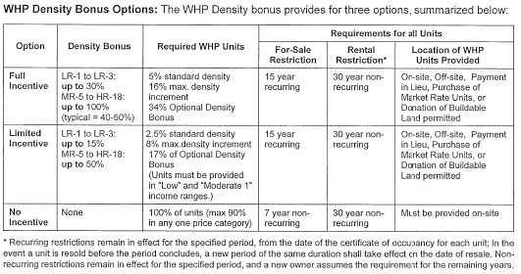

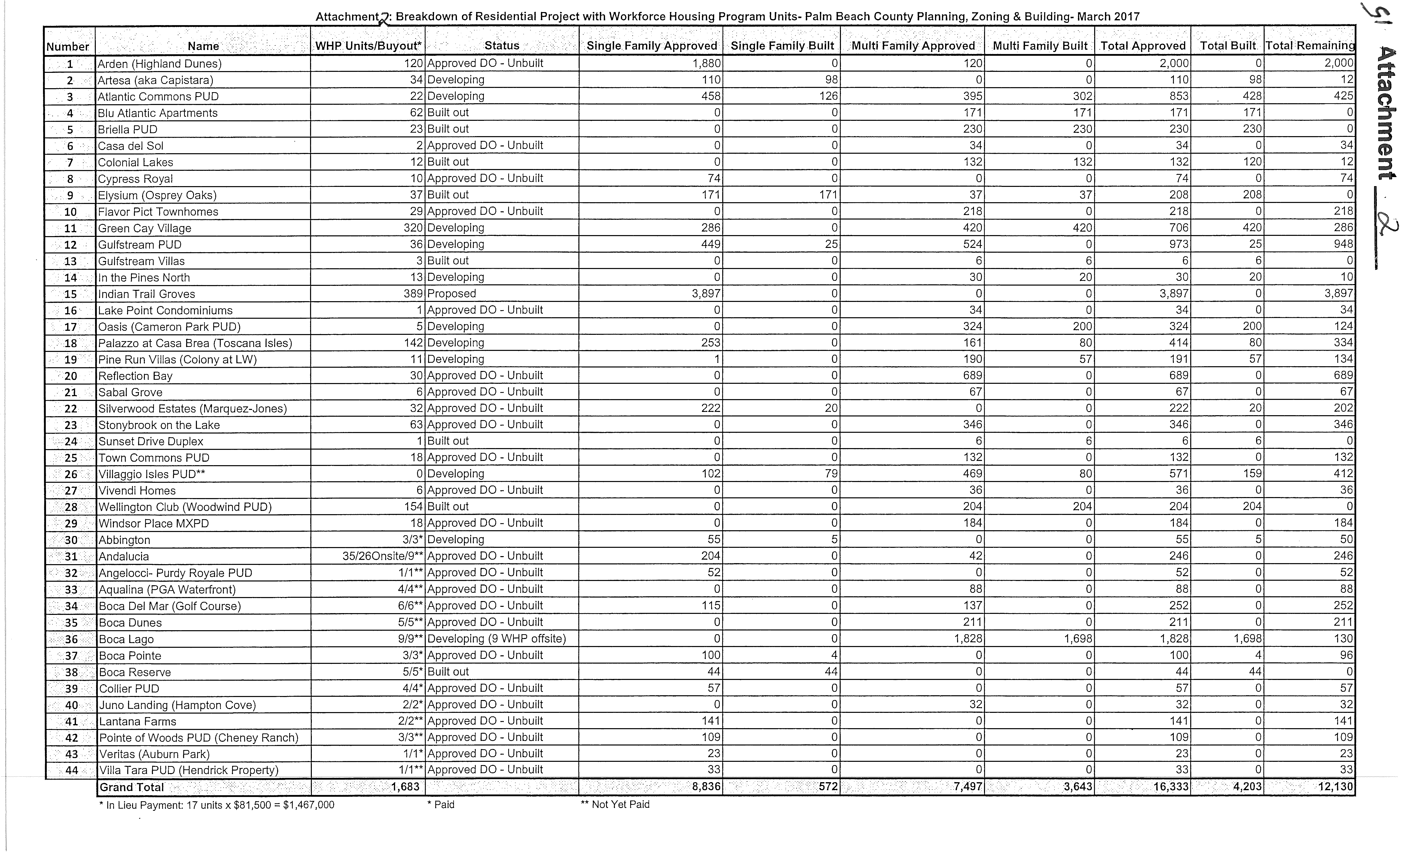

**APPENDIX F**

**Surplus Property Selections**

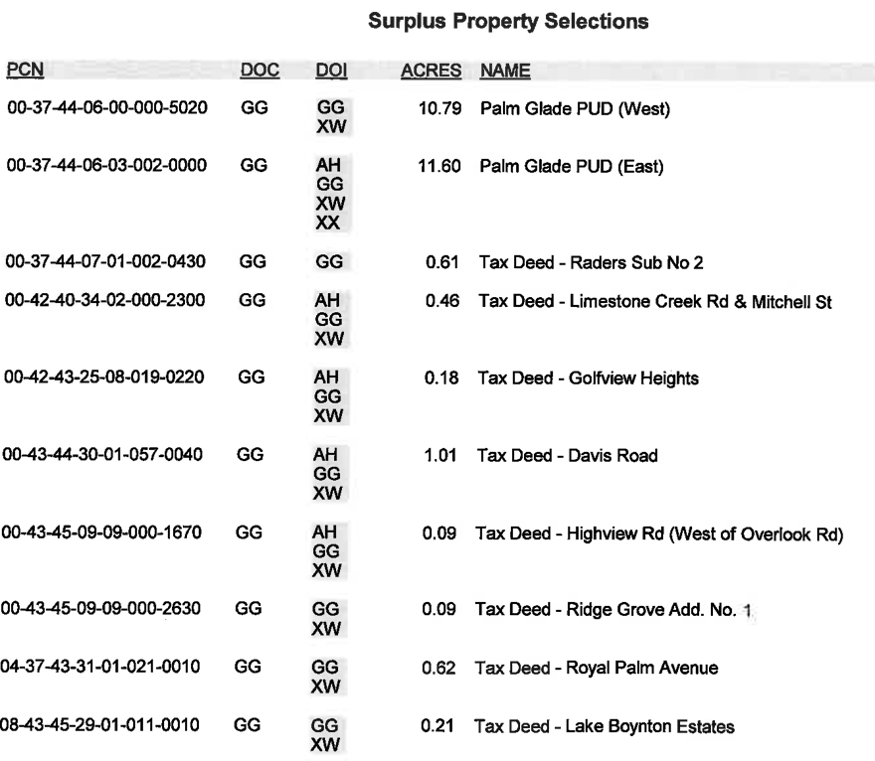

**APPENDIX G**

**Community Redevelopment Areas Map**

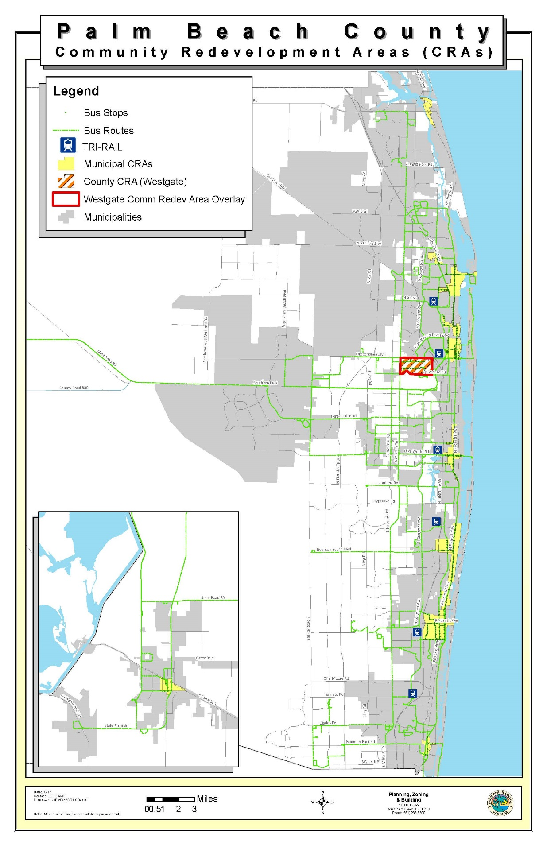

**APPENDIX H**

